To pay by check, please complete and submit this form to the address listed below:
__________________________________________________________________
Spring 2024 Advertisement: Purchasing ONE Ad to be used in ONE
printed concert program (May of 2024)

Signature (Authorized Person)__________________________________________________________

Date______________________________________________________________________________

Company__________________________________________________________________________

Contact Person(s)____________________________________________________________________

Address___________________________________________________________________________

City_________________________State___________Zip Code_______________________________

Phone_______________________Email_________________________________________________

Please place an X next to all that apply below:

Enclosed is my check, payable to Family Folk Machine, for the purchase of:

__________ 1/8 page (Business Card Size) Advertisement for $100

__________ 1/4 page Advertisement for $250

__________ 1/2 page Advertisement for $500

__________ Full-page Advertisement for $950

__________ Please use my original logo from my past sponsorships for this Ad

__________ I will be sending a new Ad or logo in JPG format by April 26, 2024

~~~~~~~~~~~~~~~~~~~~~~~~~~~~~~~~~~~~~~~~~~~~~~~~~~~~~~~~~~~~~
Thank you for your generous support for the music and mission of the Family Folk Machine!
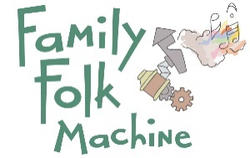

Please return the completed form to:

Family Folk Machine
P.O. Box 1421
Iowa City, IA 52244-1421

or by email to Note58us@yahoo.com

EIN: 82-5371688

