__________________________________________________________________
Spring 2024 Major Sponsorship: Purchasing ONE full-page ad to be used in
ONE printed concert program (May of 2024)
and to be included on publicity posters, fliers,
and postcards.

Signature (Authorized Person)__________________________________________________________

Date______________________________________________________________________________

Company__________________________________________________________________________

Contact Person(s)____________________________________________________________________

Address___________________________________________________________________________

City_________________________State___________Zip Code_______________________________

Phone_______________________Email_________________________________________________

Please place an X next to all that apply below:

Enclosed is my check for $1,000 (or more),
payable to Family Folk Machine, for the purchase of ONE full-page ad

__________ Please accept my check for a major sponsorship in the amount of $________________

__________ Please use my original logo from my past sponsorships for this Ad

__________ I will be sending a new Ad or logo in JPG format by April 8, 2024

~~~~~~~~~~~~~~~~~~~~~~~~~~~~~~~~~~~~~~~~~~~~~~~~~~~~~~~~~~~~~
Thank you for your generous support for the music and mission of the Family Folk Machine!
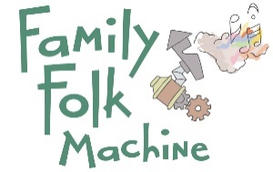

Please return the completed form to:

Family Folk Machine
P.O. Box 1421
Iowa City, IA 52244-1421

or by email to Note58us@yahoo.com

The Family Folk Machine is a nonprofit organization

EIN: 82-5371688

